Residence Hall Association
Popcorn and Cotton Candy Machine
Rental Contract
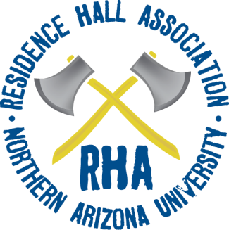

Organization: |  | Date:
Location: |  | Time:
Contact Person: |  | Phone:
E-Mail:

Machine: Popcorn  Cotton Candy | Estimated Turnout:  (If Supplies Needed, else leave blank)

Check Out Date/ Time:
Check In Date/ Time:

Agreement:
I, , acknowledge and understand the guidelines to renting the popcorn and/ or cotton candy machine(s). Only Resident Assistants, Graduate Assistants, or full-time Residence Life staff are allowed to checkout and operate the machine (s), unless special arrangements have been made with the RHA Finance Director. My hall and I are responsible for the pickup and delivery of the machine(s). I will be responsible for the cleaning and safety of the machine while it is under my supervision. If the machine breaks or malfunctions, I will inform the RHA Finance Director immediately.

Print Name | Position: RA GA RHD Other
Signature Date

*Effective August 24, 2009: Listed below are various fees/costs

